**TASK-1: Performing the ETL in Power BI**

**Project Title: Exhaustive Analysis of Indian Agriculture Sector Using Power BI**

**ETL Process**

* **Extract:** Pull data from various sources like Excel, CSV, text files, or databases.
* **Transform:** Process and clean the data to make it suitable for analysis. This can include removing duplicates, handling missing values, and formatting data.
* **Load:** Load the cleaned and transformed data into a tool or platform for further analysis or visualization.

**Analysis**

* Focuses on deriving insights and identifying facts through tools like dashboards.
* Dashboards help in presenting data in a way that supports decision-making.

**Data Stages**

* **Load:** Used after the data has been cleaned.
* **Transform:** Performed when further processing is required to make data usable.

**Views in Power BI**

* **Report View:** Focused on creating visualizations and dashboards.
* **Table View:** Displays raw data, allowing users to verify or explore the dataset.
* **Model View:** Enables users to establish relationships between different data tables, which is essential for relational analysis.

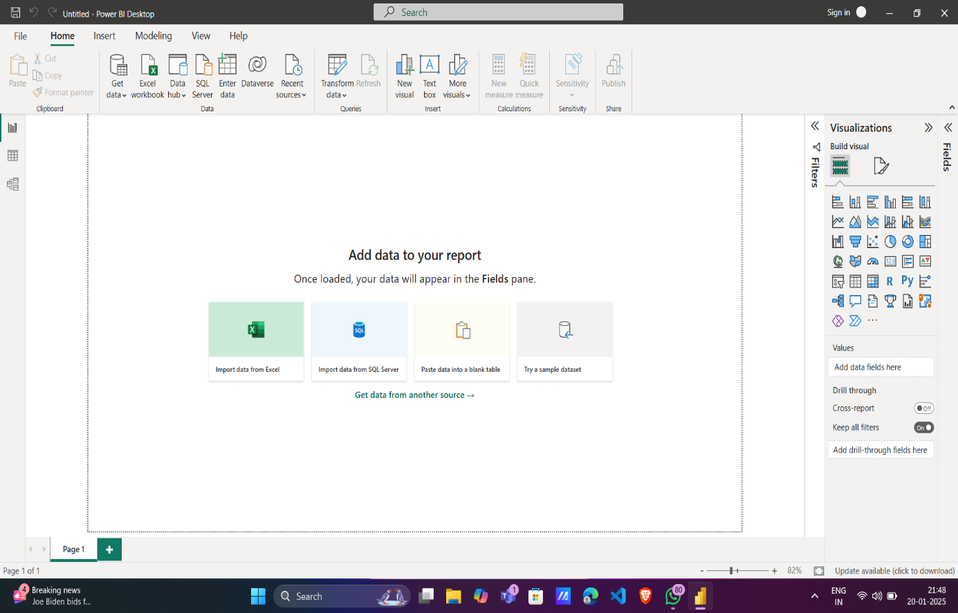**Snapshots**

Fig-1: Power BI main dashboard

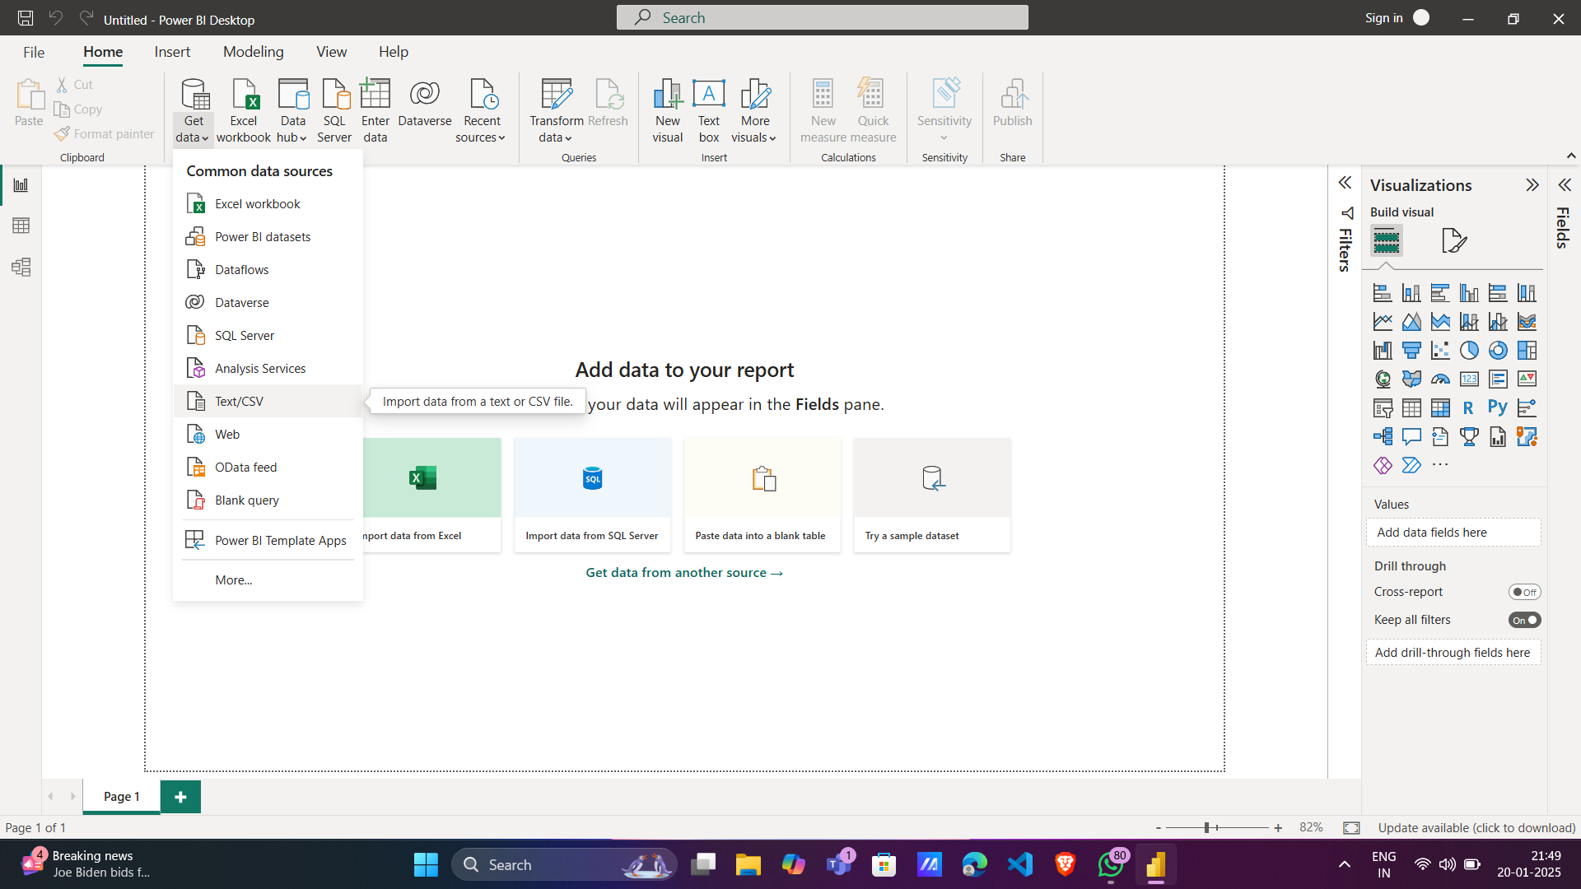

Fig-2: Exporting dataset (selecting text/csv dataset option)

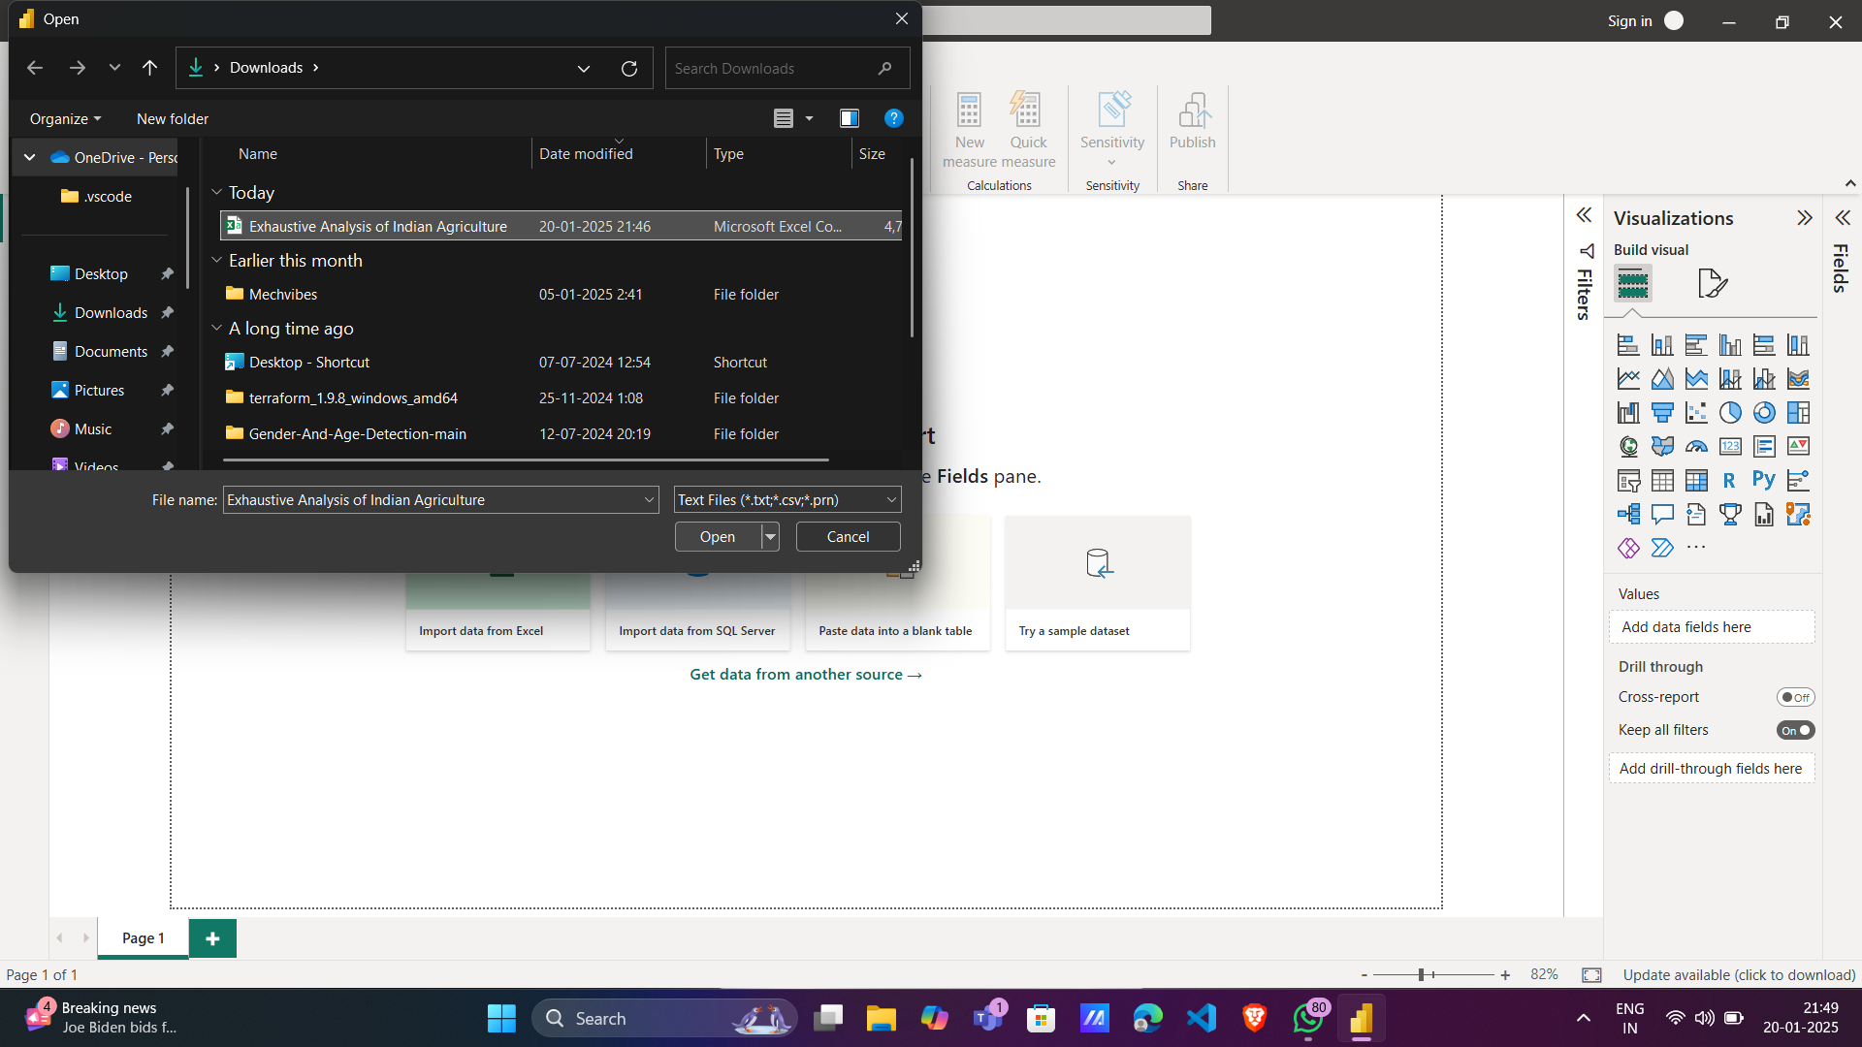

Fig-3: Selecting Exhaustive Analysis of Indian Agriculture Sector dataset from the folder

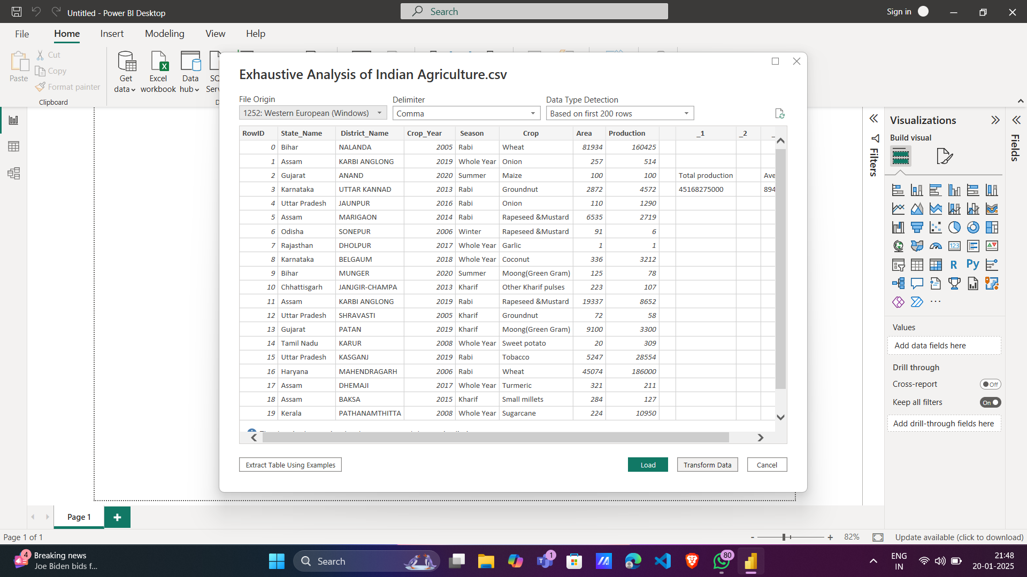Fig-4: Loading the dataset into Power BI

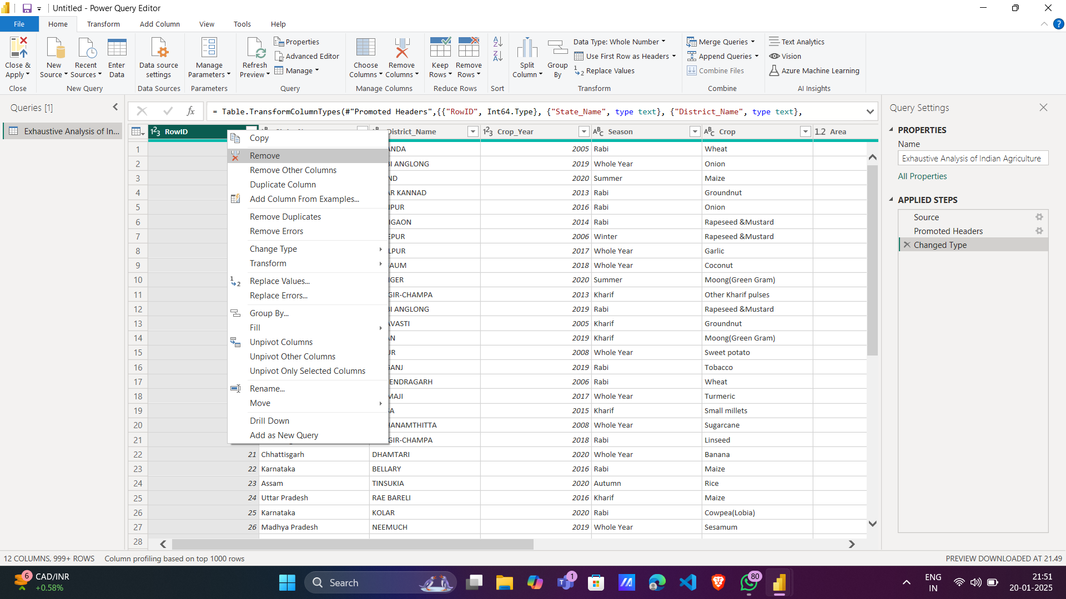

Fig-5: Removing the single column

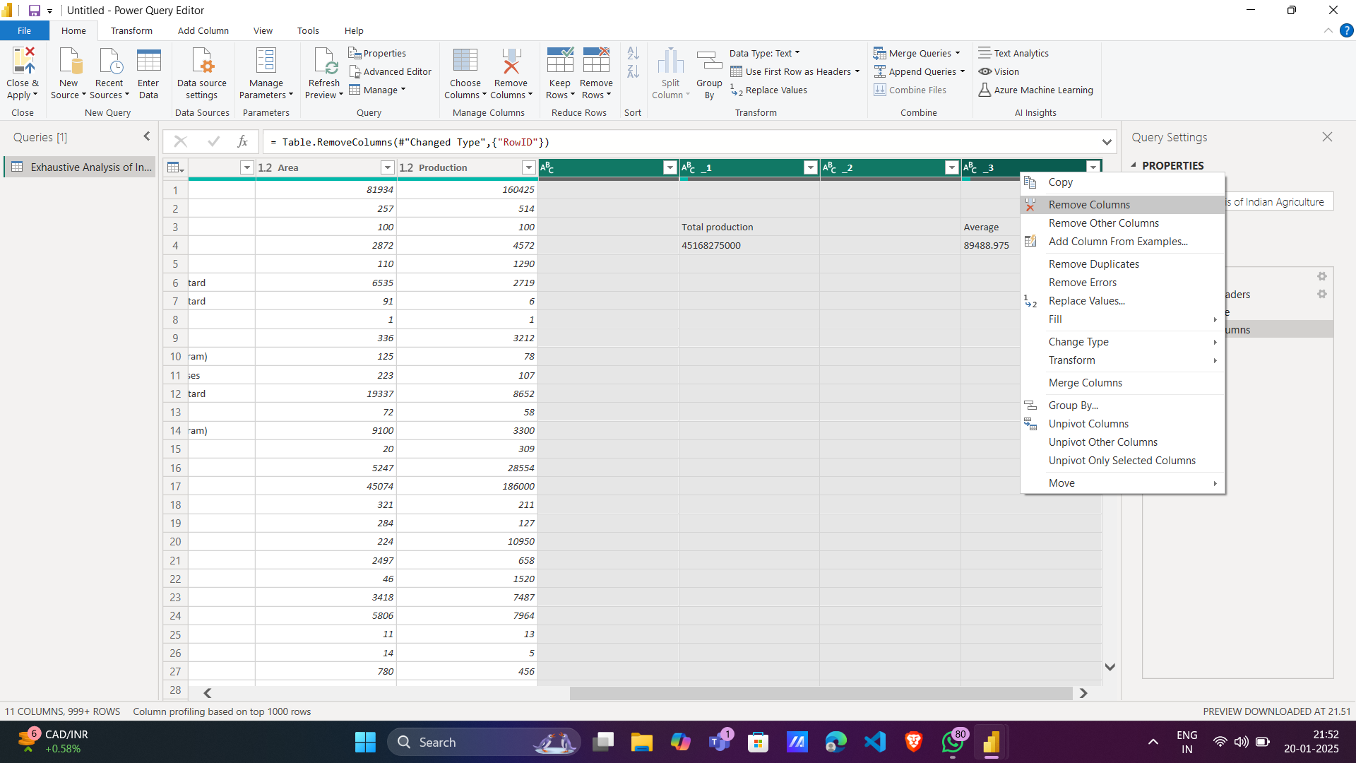

Fig-6: Removing the multiple columns

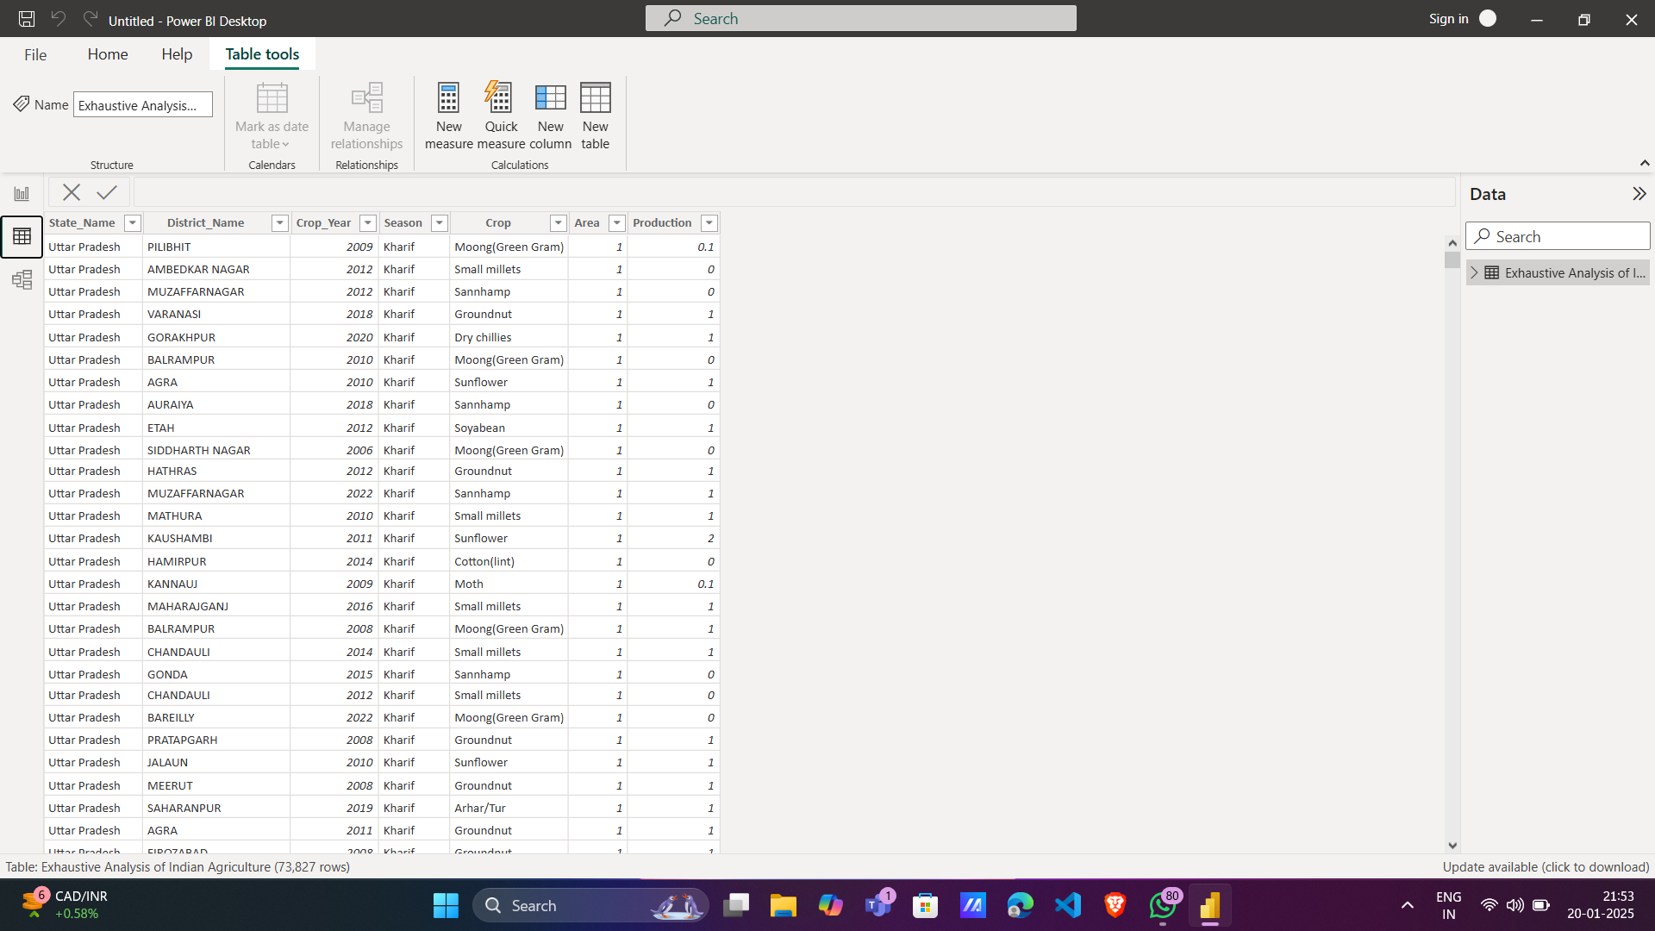

Fig-7: After performing the transformation viewing the data into the Table View